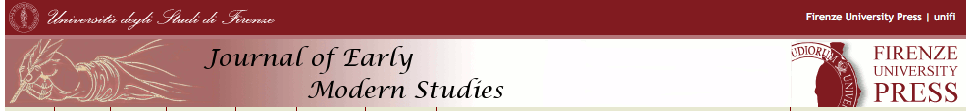

JEMS 4, 2015
Call for Papers

Service and Servants in Early Modern Culture, 1500-1750

We are now inviting contributions for Volume 4 of the Journal of Early Modern Studies, to be released online in March 2015. Jointly edited by William C. Carroll (Boston University) and Jeanne Clegg (Università Ca’ Foscari, Venice), JEMS 4, entitled Service and Servants in Early Modern Culture, 1500-1750, aims to bring together scholars from across a wide disciplinary spectrum to inquire into differences and similarities, continuities and changes in the ethics, representation and practice of service and servitude in different countries and contexts. The issue will be open to contributions on oral and visual forms of cultural expression as well as textual, and we invite studies of emerging voices and works intended for and by, as well as about, servants and service. Contributions addressing issues of class, gender, and ethnic/national representations are particularly encouraged.
Main deadlines:
1st October 2013: adhere to project and send working title and short abstract to William Carroll (wcarroll@bu.edu) and Jeanne Clegg (jfclegg@unive.it).
31st January 2014: finalize paper for submission to referees. Articles must comply with the editorial norms and must not exceed 12,000 words, including endnotes and bibliography.

All articles are published in English. Please be so kind as to have your paper revised by a native speaker.
Firenze University Press
Borgo Albizi, 28 - 50122 Firenze Tel. (0039) 055 2743051 Fax (0039) 055 2743058 E-mail: journals@fupress.com

